**Sequence Diagram:**

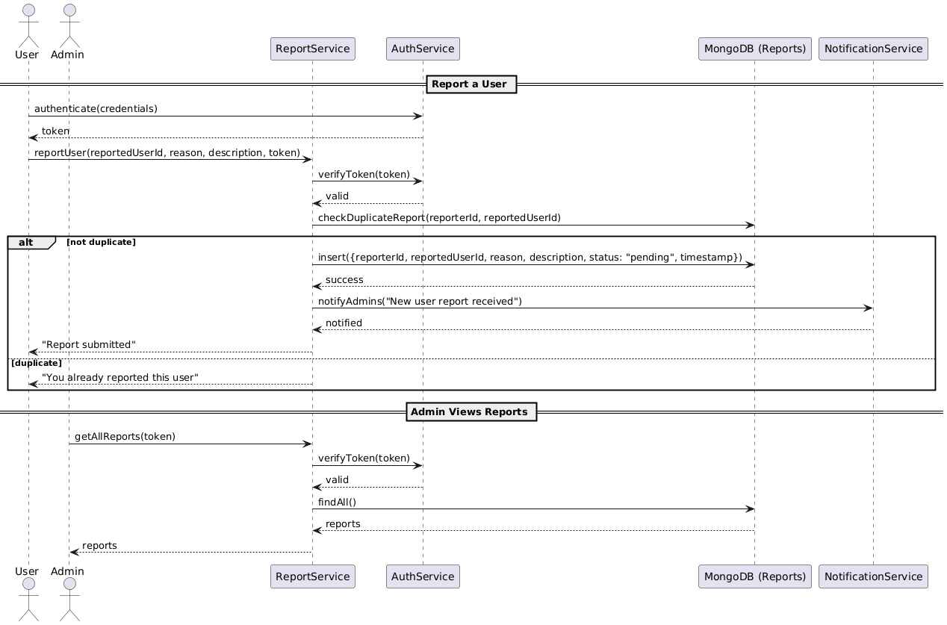

**Class Diagram:**

**State Diagram:**

**ERD:**

**Functional Requirements**

1. Users must be able to report other users.
2. Reports must include a reason and optional description.
3. The system must store the report with a timestamp and reporter’s ID.
4. Admins must be able to view all reports.
5. Admins must be able to mark a report as “Reviewed” or “Action Taken.”
6. A user can be reported multiple times by different users.

**Non-Functional Requirements**

1. Report submission must be processed within 2 seconds.
2. All reports should be encrypted in storage.
3. Only admins and moderators can access reported data.
4. The system must store reports for at least 6 months.
5. The UI must prevent duplicate reports from the same user.